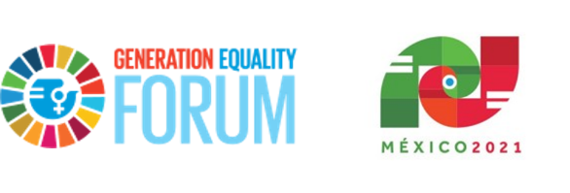

Generation Equality Forum, Mexico 2021
Community Agreement and Guidelines

The Generation Equality Forum is a global gathering for gender equality, convened by UN Women and co-chaired by France and Mexico, in partnership with civil society and youth constituencies from across the world. The Forum will kick-off in Mexico City in March 2021 and culminate in Paris in June 2021.
The open exchange of ideas and the freedom of thought and expression are central to the Forum’s aims and goals. These require an environment that recognizes the inherent worth of every person and group; fosters dignity, understanding, and mutual respect; and embraces diversity.
The Forum will provide support and space for meaningful participation to enable a broad spectrum of viewpoints and constructive dialogue. All participants attending the Mexico Forum virtual platform of the Generation Equality Forum agree to adhere to the following Community Agreement and Guidelines.
The Values of the Generation Equality Forum, Mexico
Diversity and Inclusion: Forum participants are diverse in abilities, backgrounds, identities, experiences, and views. Participants come together in this Forum to celebrate and recognize that strength comes from this diversity united in the goal of achieving gender equality.
Human Rights: One of the central purposes of the Generation Equality Forum is the full respect, protection, and promotion of women’s human rights. Participants in the Forum recognize that all human rights are indivisible, interdependent, inalienable, and universal.
Transformation: The Generation Equality Forum recognizes that it is essential to transform gender norms that perpetuate inequalities in order to achieve its goals and chart a course toward a more just and equal world.
Cooperation: The success of the Generation Equality Forum will rely on the cooperation, solidarity and collective action across stakeholders, movements and borders.
Principles of Participation in the Generation Equality Forum, Mexico
The Generation Equality Forum is intended to be an important platform for respectful exchange on issues of gender equality embodying the values noted above.
By signing on to this platform, you agree to these terms and understand that any breach of this agreement and its guidelines can lead to your participation being restricted or removed and your content being deleted from the site.

Explicit Agreement with the Forum’s Community Guidelines
I have read the Community Guidelines and I understand that the Generation Equality Forum is a space that:
- Allows for respectful interaction and online dialogue and exchange.
- Recognizes, values and celebrates diversity.
- Uses respectful and inclusive language that recognizes the diversity among Forum participants.
The Generation Equality Forum will not tolerate the following:
- Any form of cyber harassment and violence, and actions that perpetuate oppressive systems, such as classism, ageism, ableism, racism, misogyny, heterosexism, or transphobia, including hate speech.
- Profane, explicit, or harmful language.
- Scams, monetary requests, advertisements, or phishing of any kind.
Forum participants violating these rules will be subject to the restriction or revocation of their online engagement privileges, including using the chat function on the online platform. At the direction of the organizers, violation of these principles could also lead to the withdrawal of participants’ overall participation in the Forum.
By registering as participant in the Generation Equality Forum Mexico, you agree to observe the Forum’s above guidelines, and understand that any breach could lead to your content being deleted and your withdrawal from the Forum platform.

